as such. The shoulder is bowing and rotating, the elbow and the wrist are only bowing and the hand itself is rotating.

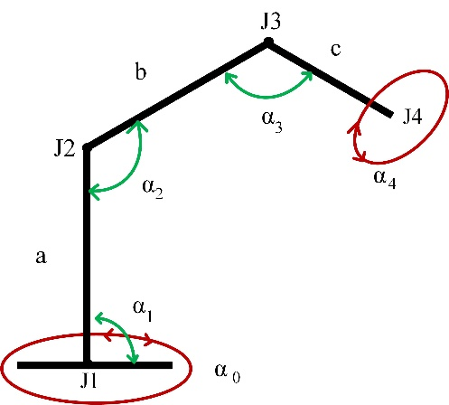

Figure 3.1. Five degree of freedom

**3.2. Hardware components**

This section will include components selection, their specifications, software developments, consideration and the detail of about them.

3.2.1. Component selection

* Arduino Uno
* Servo Motor
* Bluetooth module
* Gripper

3.2.1.1. Microcontroller

The microcontroller has played an importance role which is acted as computer with most of necessary support chips on board because each of the computer contains CPU, RAM and input/output. In the other side, microcontroller is a system of self-contained with peripherals, memory and a processor that can be used as an embedded system. Most of the embedded in other consumer products or machinery are using programmable microcontroller such as peripherals, automobiles, phones and household appliances for computer systems. Since microcontroller contain embedded inside it so there is a new name was added to the microcontroller which is embedded controller that means microcontroller can control the functionality, action, feature and movement of the thesis and product. Every mission, duty or task was dedicated by microcontroller and it is able to run the specific program, since the feature of the microcontroller were always be there. The feature or function of a microcontroller is to send a signal to specific device or component by taking an input from the controlled device.

3.2.1.2. Arduino Uno Microcontroller

Although microcontroller type PIC is usually used in programming and software field. Arduino has become very popular in the world in recent times. It is based on Arduino’s past wiring and processing projects. Processing is written for non-programming users. Arduino wiring is produced on the basis of the programming language. The common feature of both is that it provides an environment where even the basic knowledge of electronics and programming can easily design. Arduino is now becoming more and more common nowadays. Even unmanned aerial vehicles made with Arduino, which is used almost every field, are visible.

The causes of the spread of Arduino at such a rapid rate are;

* It can be used on all platforms due to the simplicity of the development environment with driver usage.
* With the help of the advanced library, even complex operations can be easily solved.
* Program written in Arduino can run fast because they are not run on any other platform.
* There is a lot of hardware support that is compatible with Arduino and can work together.
* Communication with the environment is easy because it is open source.
* If there are any problem due to a large number of Arduino users, the solution can be easily reached.

The Arduino Uno is a small, full and breadboard friendly Arduino card that houses a microcontroller or ATmega328 microcontroller. It has almost same functions as the Arduino Duemilanove. Arduino is designed and used by Uno Gravitech. The Arduino Uno offers a variety of possibilities for communication with a computer, another Arduino, or other microcontrollers. The ATmega328 supports UART TIL serial communication, accessible via the RX and TX pins. An FTDI on the card channels the FT232RL serial communications via USB and the FTDI drivers and the writing on the computer appear as a virtual com port. The RX and TX LEDs on the card flash on the FTDI chip while the USB den serial cable and the USB is transmitting data. The Software Serial library allows serial communication over any of the digital pins of the Arduino Uno. The ATmega328 microcontroller also supports 12C (TWI) and SPI communications.

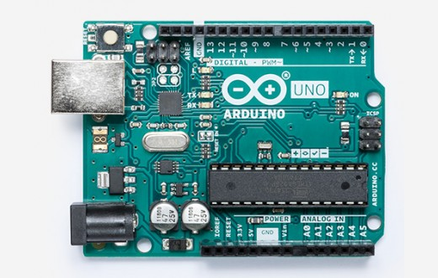

Figure 3.2. Arduino Uno Microcontroller

3.2.1.3. Servo Motor

A servo is a small device that has an output shift. This shaft can be positioned to specific angular positions by sending the servo a coded signal. As long as the coded signal exists on the input line, the servo will maintain the angular position of the shaft. As the coded signal changes, the angular position of the shaft changes. In practice, servos are used in radio controlled airplanes to position control surfaces like the elevators and rudders. They are also used in radio controlled cars, puppets, and course, robots.

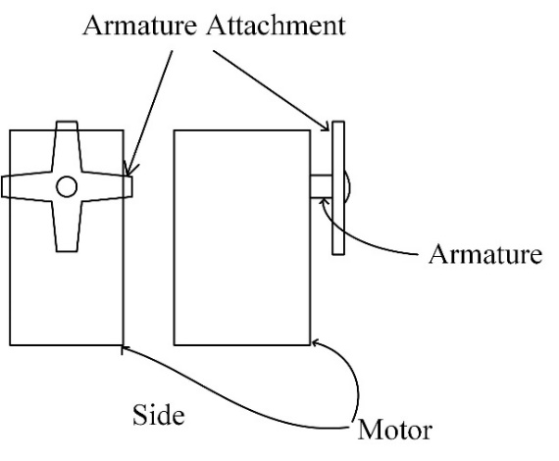

Figure 3.3. Servo notations

Servos are extremely useful in robotics. The motors are small, as shown in the picture below, have built in control circuitry, and are extremely powerful for their size. A standard servo such as the Futaba S-148 has 42oz/inches of torque, which is pretty strong for its size. It also draws power proportional to the mechanical load. A lightly loaded servo, therefore, doesn’t consume much energy. The guts of a servo motor are shown in the picture below.

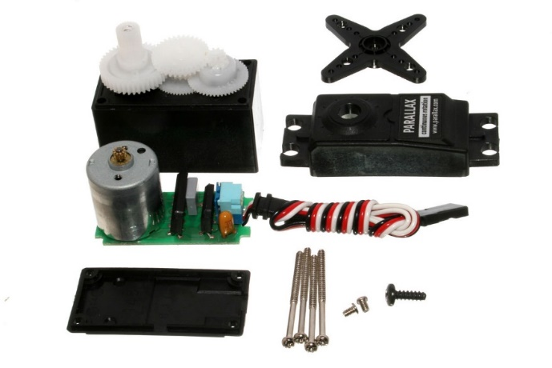

Figure 3.4. Disassembled Servo

The servo motor has some control circuits and a potentiometer that is connected to the output shaft. In the picture below, the pot can be seen on the right side of the circuit board. This pot allows the control circuitry to monitor the current angle of the servo motor. If the shaft is at the correct angle, then the motor shutoff. If the circuit finds that the angle is not correct, it will turn the motor the correct direction until the angle is correct. The output shaft of the servo is capable of travelling somewhere around 180 degrees. Usually, it’s somewhere in the 210 degree range, but it varies by manufacture. A normal servo is used to control an angular motion of between 0 and 180 degrees. A normal servo is mechanically not capable of turning any father due to a mechanical stop built on to the main output gear.

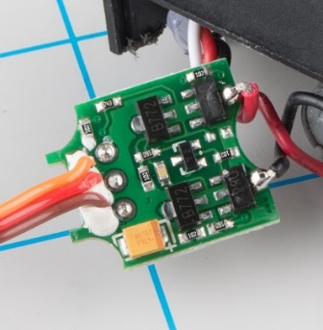

Figure 3.5. Servo circuit

The amount of power applied to the motor is proportional to the distance it needs to travel. So, if the shaft needs to turn a large distance, the motor will run at full speed. If it needs to turn only a small amount, the motor will run at a slower speed. This is called proportional.

The control wire is used to communicate the angle. The angle is determined by the duration of a pulse that is applied to the control wire. This is called Pulsed Width Modulation. The servo expects to see a pulse every 20 milliseconds. The length of the pulse will determine how far the motor turns. A 1.5 milliseconds pulse, for example, will make the motor turn to the 90 degree position. If the pulse is shorter than 1.5ms, then the motor will turn the shaft to closer the shift to closer to 0 degrees. If the pulse is longer than 1.5ms, the shaft turns closer to 180 degrees. So we generate the desired pulse can be generated with the help of microcontroller. The servo uses three wires: white carriers the control signal, red carriers power and black is ground.

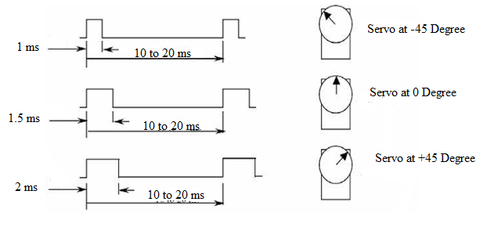

Figure 3.6. Servo pulses

3.2.1.4. MG995 Servo Motor

This is the most famous servo made by Tower Pro. MG995 is a digital metal gear high torque servo for airplane, helicopter, RC-car from 10 to 6-th Scale Truggy and Monster and many RC model.

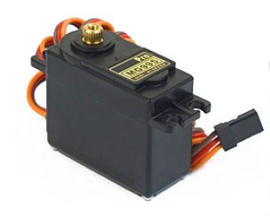

Figure 3.7. MG995 Servomotor

|  |  |
| --- | --- |
| Characteristics | Specification |
| Weight | 55g |
| Dimension | 40.7×19.7×42.9mm |
| Stall torque | 9.4kg/cm (4.8v); 11kg/cm (6v) |
| Operating speed | 0.2sec/60degree |
| Operating voltage | 4.8~6.6v |
| Gear type | Metal gear |
| Temperature range | 0-55degree |
| Dead bandwidth | 1µs |

Table 3.1. Specification of MG995 Servo Motor

3.2.1.5. SG90 Servo Motor

Micro servo motor SG90 is a tiny and lightweight server motor with high output power. Servo can rotate approximately 180 degree (90 in each direction) and works just like the standard kinds be smaller. To control theses servos, any servo code, hardware or library can be used to control these servos.

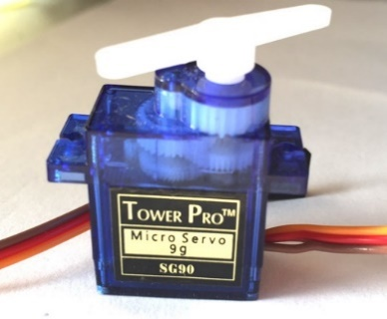

Figure 3.8. SG90 Servomotor

Table 3.2. Specification of SG90 Servo motor

|  |  |
| --- | --- |
| Characteristic | Specification |
| Weight | 9g |
| Dimension | 22.2×11.8×31mm |
| Stall torque | 2.8kg/cm |
| Speed | 0.1s/60degree |
| Gear Type | plastic |
| Rotation | 0-180 degree |
| Voltage | 4.8V |

3.2.1.6. MG996R Servo Motor

This High-Torque MG996R Digital Servo features metal gearing resulting in extra high 10kg stalling torque in a tiny package. The MG996R is essentially an upgraded version of the famous MG995 servo, and features upgraded shock-proofing and a redesigned PCB and IC control system that make it much more accurate than its predecessor. The gearing and motor have also been upgraded to improve dead bandwidth and centering. The unit comes complete with 30cm wire and 3 pin 'S' type female header connector that fits most receivers, including Futaba, JR, GWS, Cirrus, Blue Bird, Blue Arrow, Corona, Berg, Spektrum and Hitec.

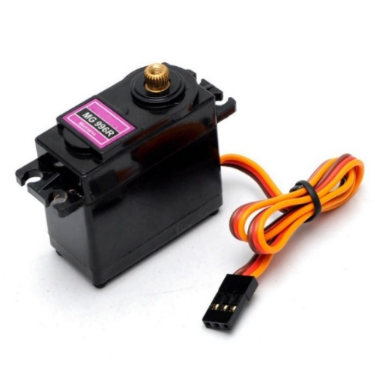

Figure 3.9. MG996R Servo Motor

Table 3.3. Specifications of MG996R Servo Motor

|  |  |
| --- | --- |
| Characteristic | Specification |
| Weight | 55g |
| Dimension | 40.7 x 19.7 x 42.9 mm approx. |
| Stall torque | 9.4 kg-cm (4.8 V ), 11 kg-cm (6 V) |
| Operating speed | 0.17 s/60º (4.8 V), 0.14 s/60º (6 V) |
| Operating voltage | 4.8 V a 7.2 V |
| Running current | 500 mA |
| Stall current | 2.5 A (6V) |
| Dead bandwidth | 5 µs |
| Temperature range | 0-55 degree |

3.2.1.7. Bluetooth Module HC-05

HC-05 module is an easy to use Bluetooth SPP (Serial Port Protocol) module designed for transparent wireless serial connection setup. The HC-05 Bluetooth Module can be used in a Master or Slave configuration, making it a great solution for wireless communication. This serial port Bluetooth module is fully qualified Bluetooth V2.0+EDR 3Mpbs modulation with complete 2.4GHz radio transceiver and baseband. It uses CSR Blue core 04-External single chip Bluetooth system with CMOS technology and with AFH (Adaptive Frequency Hopping Feature).

The Bluetooth module HC-05 is a MASTER/SLAVE module. By default the factory setting is SLAVE. The role of the module can be configured only by AT COMMANDS. The slave modules cannot initiate a connection to another Bluetooth device, but can accept connections. Master module can initiate a connection to other devices. The user can use it simply for a serial port replacement to establish connection between MCU and GPS, PC to your embedded project, etc.

Hardware Feature:

* Typical -80dBm sensitivity
* Up to +4dBm RF transmit power
* 3.3 to 5V I/O
* PIO (Programmable Input/Output) control
* UART interface with programmable baud rate
* With integrated antenna
* With edge connector

Software Feature:

* Slave default Baud rate:9600, Data bits:8,Data bit:8
* Stop bit 1, Parity: No parity
* Auto-connect to the last device on power as default
* Permit pairing device to connect as default.
* Auto–pairing PINCODE ‘1234’ as default

Pin Description:

The HC-05 Bluetooth Module has 6 pins. They are as follows:

* ENABLE: When enable is pulled LOW, the module is disabled which means the module will not turn and fail to communicate. When enable is left opened or connected to 3.3V, the module is enabled i.e. the module remains on and communication also takes place.
* VCC: Supply Voltage 3.3V to 5V.
* GND: Ground pin.
* TXD and RXD: These two pins acts an UART interface for communication.
* STATE: It acts as a status indicator. When the module is not connected to / paired with any other Bluetooth device, signal goes Low. At this low state, the led flashes continuously which denotes that the modules is a bit not paired with other device. When this module is connected to/paired with any other Bluetooth device, the signal goes high. At this high state, the led blinks with a constant delay say for example 2s delay which indicates that the module is paired.

This is used to switch the module into AT command mode. To enable AT command mode, press the button switch for a second. With the help of AT commands, the user can change the parameters of this module but only when the module is not paired with any other BT device. If the module is connected to any other Bluetooth device, it starts to communicate with that device and fails to work in AT command mode.

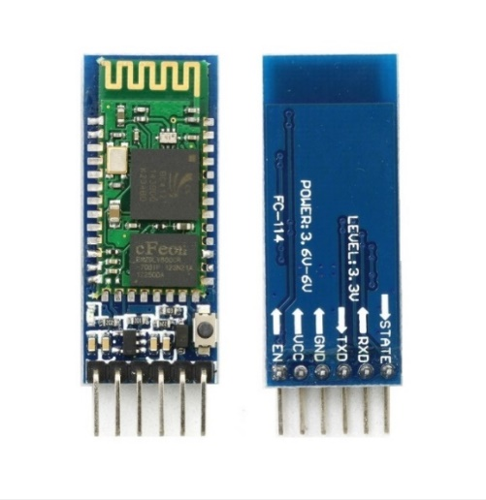

Figure 3.10. Bluetooth module HC-05

3.2.1.8. Gripper

The end effector is probably one of the most important and most complex parts of the system. The end effector varies mainly according to the application and the task that the robotic arm accomplishes for; it can be pneumatic, electric or hydraulic. Since the robotic arm is based on an electric system, electric basis offend effector may be chosen. Besides, the main application of the system is handling, according, the recommended type of the end effector is a gripper. A gripper is a device which enables the holding of an object to be manipulated. The easier way to describe a gripper is to think of the human hand.

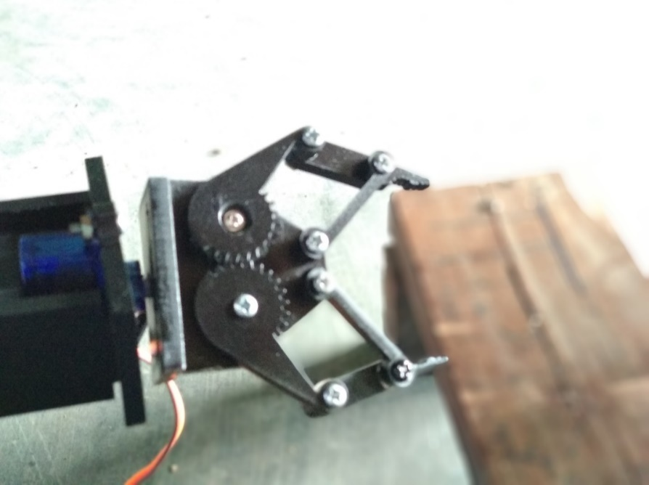

Figure 3.11. Gripper

**3.3 Summary**

This chapter discuss about the design of robotic arm and the next chapter will be described about the Arduino software implementation of the system.